# Team Name: CARRUS

* **Team members details: 1. *Vishnu Vardhan V (SQL Database Backend) (Leader)***
  1. ***Shruthi M (SQL Database Backend)***
  2. ***Savion Mario Sequeira (Java Functionality Backend)***
  3. ***Shreyas Chandrashekar (Java Swing GUI Frontend)***

# Selected theme: Smart Cities

* **Problem Statement:** The average person spends around 60 hours on grocery shopping per year, imagine what one could do with even half of those hours back in their life. Introducing to you **“Carrus”,** an on the go shopping solution for the urban dweller. **“Carrus”** will be an intuitive kiosk spread out around the city which will cater to your “on the go” needs.
* **Description of the desired application:** We are building a rudimentary prototype kiosk with only GUI to showcase as to what our application will perform along with key features. Our competitors are apps like BigBasket, Grofers. Our solution gives a boost to local grocery store owners by providing them a helping hand by using technology. Our goal is to have kiosks all over the city and make **“Carrus”** a household name.
* **Solutioning and Methodology:** If you notice while everything is moving forward grocery stores have remained the same. Even fast food chains are moving forward by building kiosks. We propose to do the same in grocery stores via physical kiosks.

One might question the need of advancing grocery stores with the rise of companies like BigBasket, but we are looking at solving the problem of immediate grocery needs.

For example imagine a situation where you are out and about with friends or family and you are in need for a snack or a drink, or you are on the way home and you need to buy a few groceries immediately, you can walk up to the nearest **“Carrus”** and search for you item or store and purchase the needful and collect them on your way home.

This is a huge market to capture.

The impact would make the shopping experience much quicker and faster for customers and would reduce crowding of lines the checkout counter, especially during this COVID19 pandemic. This will benefit customers buying only small number of items too.

The core software would be a well-built DBMS software integrated with our Java application.

The hardware component would require physical kiosks all over the city connected to the database of each grocery store.

The main goal would be to build trust with the vendors that this solution would be beneficial to them. It would be effective in boosting sales and advertising the stores at the same time.

This can be easily scaled to an entire city or country as and when more and more grocery stores get involved and interested with integrating with our solution.

Our solution can be leveraged by all grocery store vendors.

* **Tech Stack:** We will use Java for developing the main application for the prototype and for backend connectivity we will use MySQL. The GUI will be made using Swing in Java.
* **Visualizations:**

1. Demo Map

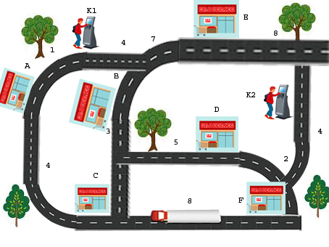

1. ER diagram (Database)

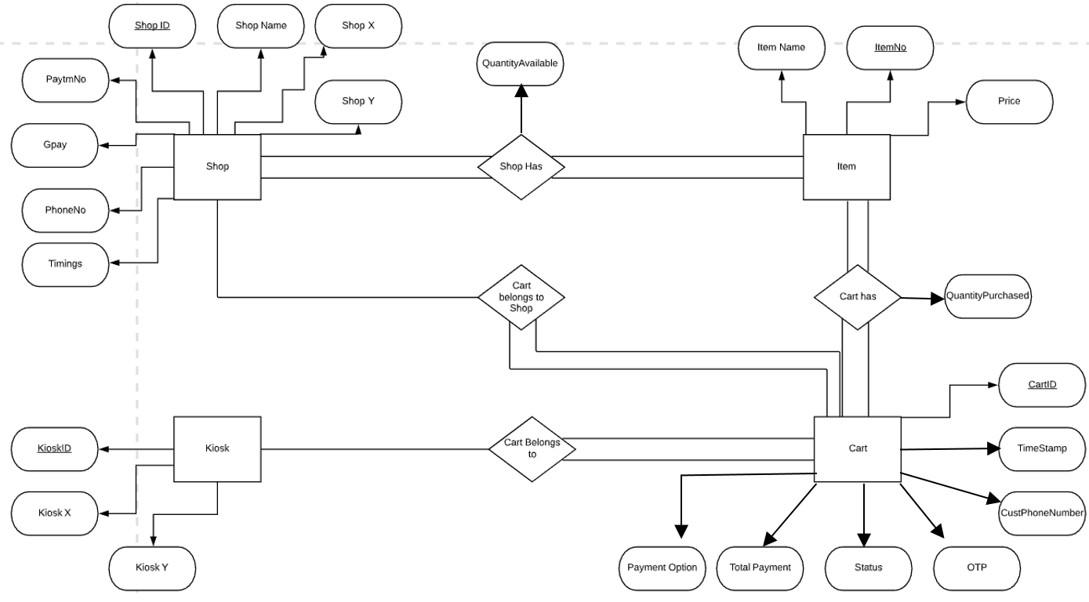

1. Schema (Database)

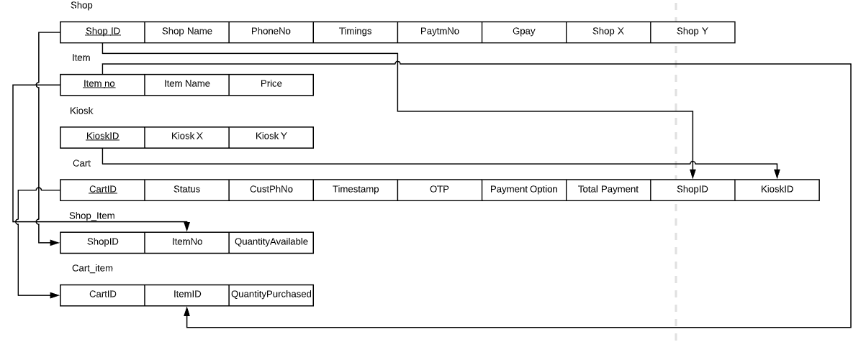

1. GUI layouts

* **Scope and Future Improvements:**

1. Functionalities could be extended to be used during emergencies for reaching out to the police, hospitals., allowing people to report to nearby emergency services.
2. It can generate revenue by allowing companies to take up advertising space in the kiosks.